

**LAB # 3**



**DATED:**

**17th October, 2022**

**SUBMITTED TO:**

**Engr. Rehmat Ullah**

**CSE-202L Digital Logic Design Lab**

**Fall 2022**

**SUBMITTED BY:**

**Ali Asghar(21PWCSE2059)**

**Suleman Shah(21PWCSE1983)**

**Abu Bakar(21PWCSE2004)**

**Department of Computer Systems Engineering**

**University of Engineering & Technology, Peshawar**

De-Morgan’s Theorem

CSE-202L: Digital Logic Design Laboratory

OBJECTIVE:

* To Experimentally verify the De-Morgan’s theorems using two input variables

COMPONENTS:

* IC’s
  + 7404 Hex Inverter
  + 7408 Quad-2-Input AND Gate
  + 7432 Quad-2-Input OR Gate
* LED’s
* Dip Switch
* 3 x 1KΩ Resistors

DE MORGAN’S THEOREMS:

De-Morgan’s Theorems are basically two sets of rules or laws developed from the Boolean expressions for **AND**, **OR** and **NOT** using two input variables, **A** and **B**. These two rules or theorems allow the input variables to be **negated** and **converted** from one form of a **Boolean function** into an **opposite form**.

STATEMENT:

According to **De** **Morgan's theorem**, a **NAND gate** is **equivalent** to an **OR gate** with inverted inputs. Similarly, a **NOR gate** is **equivalent** to an **AND gate** with inverted inputs.

DIAGRAMATICALLY:

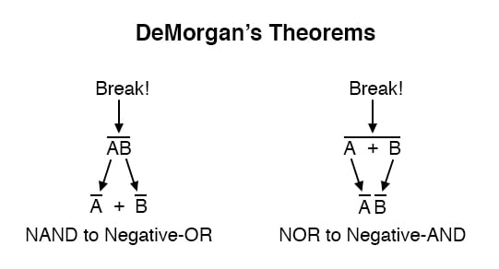

PROCEDURE:

1. First Build the circuit for left part of equation (a) as shown in figure 3.1 and monitor the behavior of LED for different test inputs
2. Then complete the circuit of figure 3.2 for the right part of equation (a) and complete the truth table 3.1 by testing each combination of inputs of appropriate switches
3. Compare both the column results and check whether equation (a) is verified or not
4. Repeat the above process by building the circuits of figure 3.3 and 3.4 and comparing its results for De-Morgan's theorem verification of equation (b).

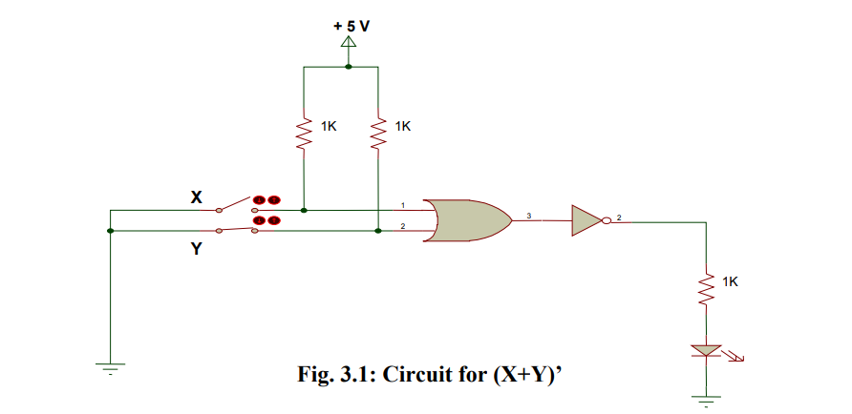

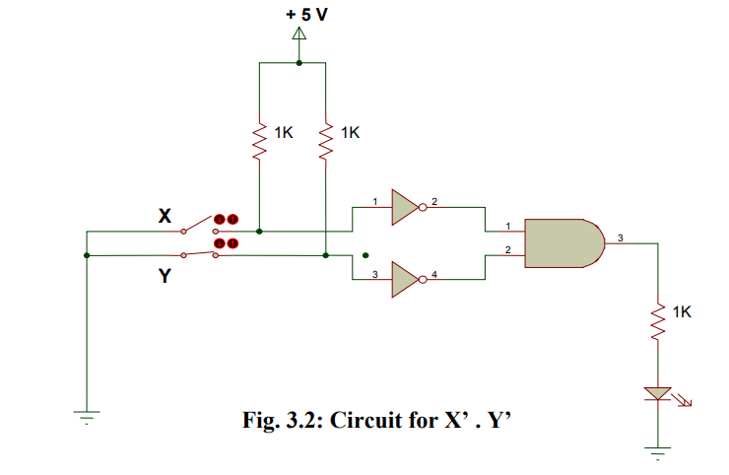

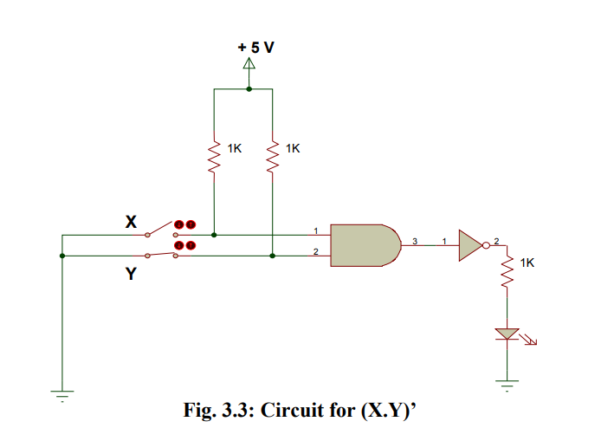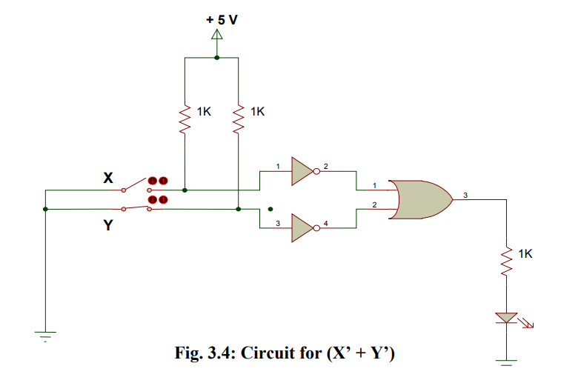

LAB WORK:

THEOREM 1:

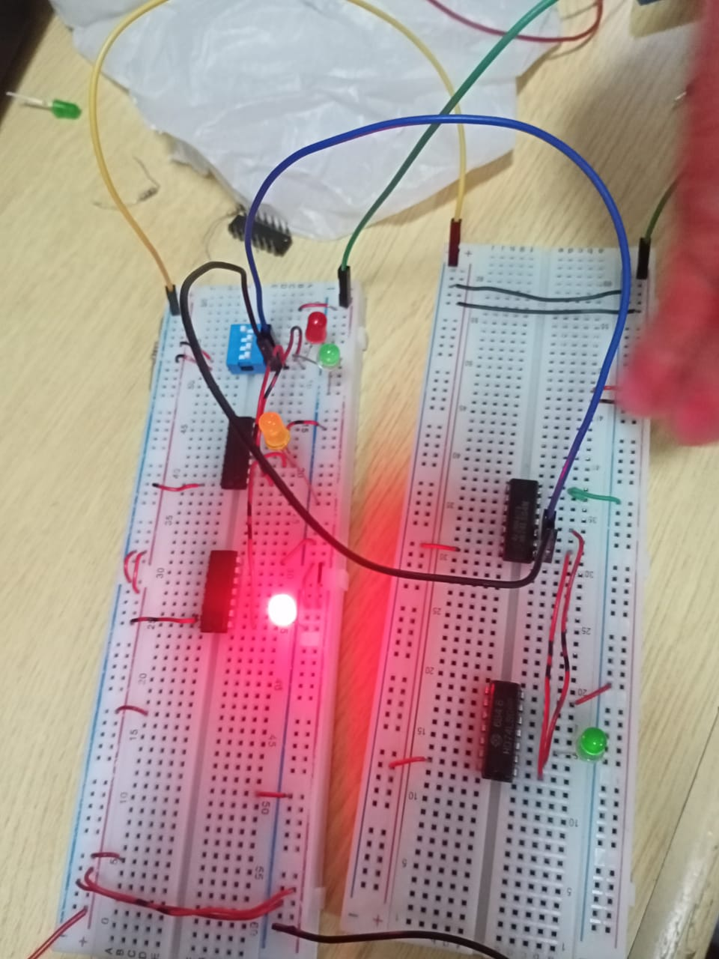

THEOREM 2: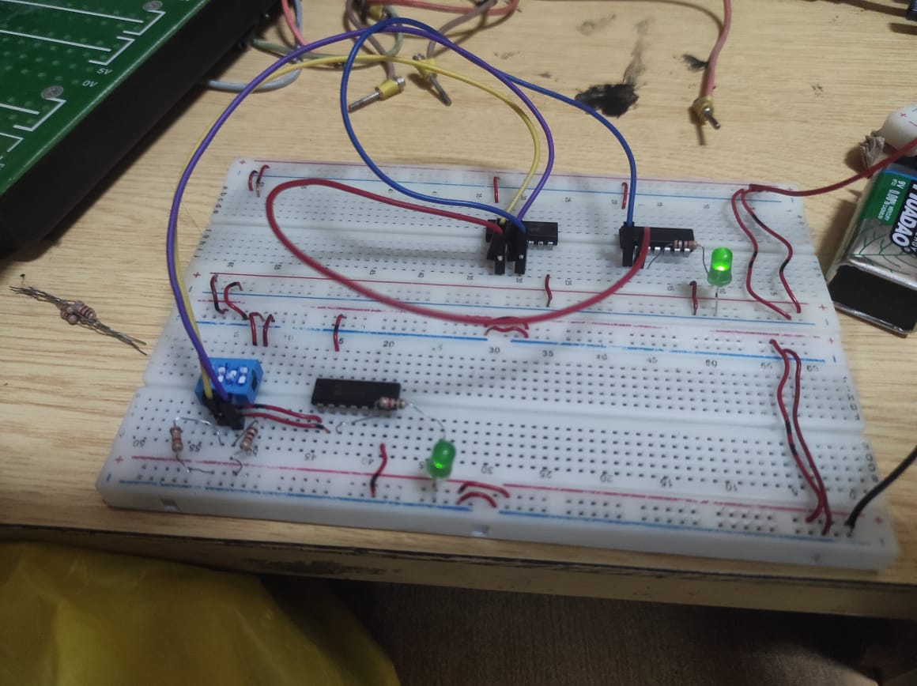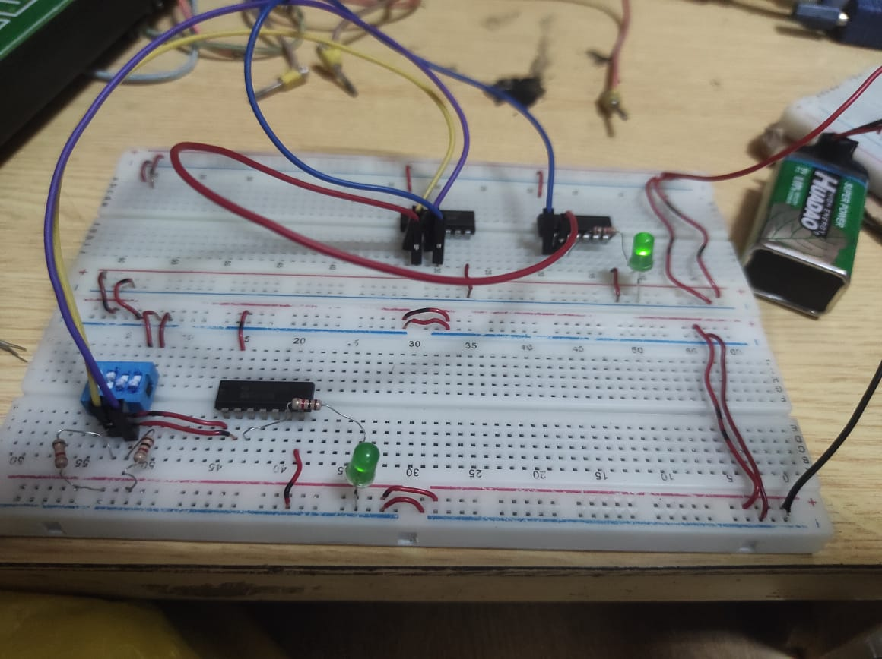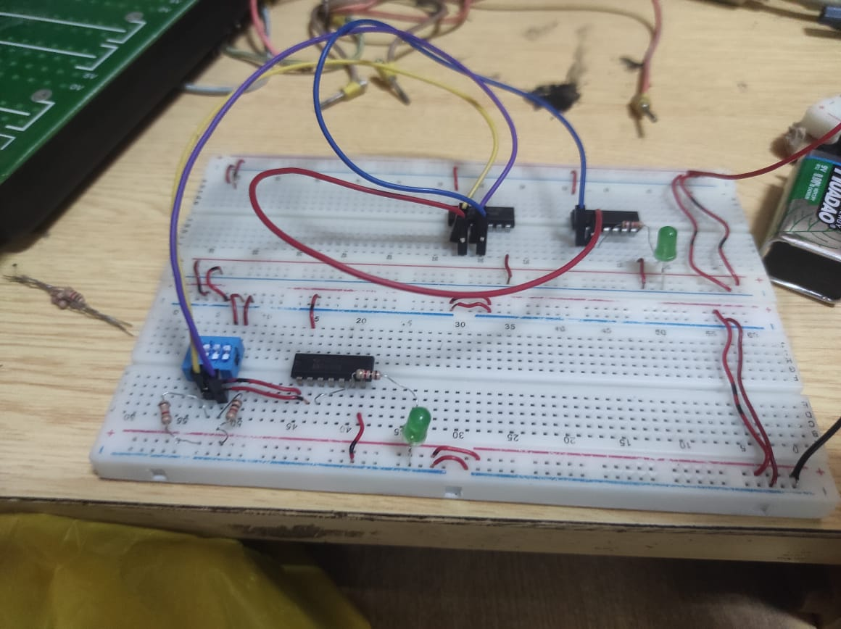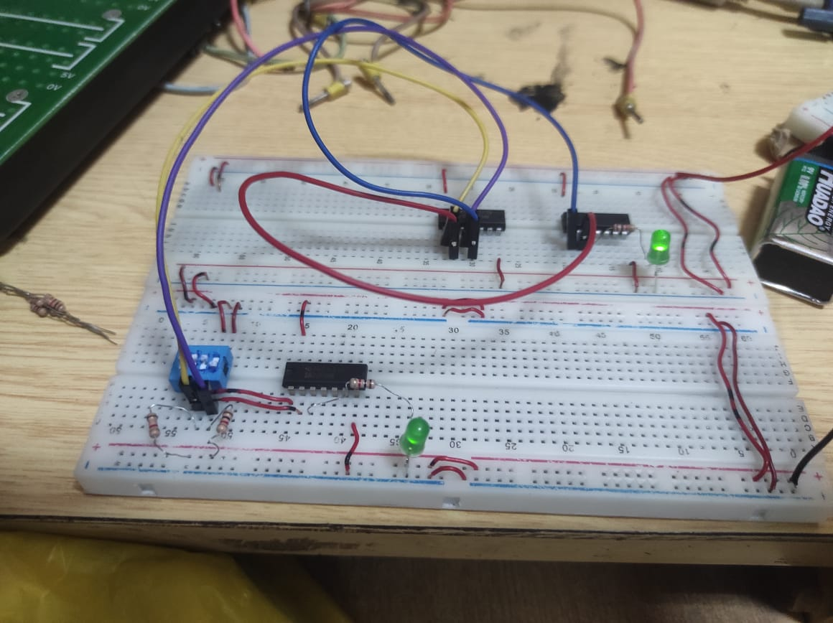

LAB READINGS:

Truth Table 3.1

|  |  |  |  |
| --- | --- | --- | --- |
| X | Y | (X+Y)’ | X’.Y’ |
| 0 | 0 | 1 | 1 |
| 0 | 1 | 0 | 0 |
| 1 | 0 | 0 | 0 |
| 1 | 1 | 0 | 0 |

|  |  |  |  |
| --- | --- | --- | --- |
| X | Y | (X.Y)’ | X’+Y’ |
| 0 | 0 | 1 | 1 |
| 0 | 1 | 1 | 1 |
| 1 | 0 | 1 | 1 |
| 1 | 1 | 0 | 0 |

Truth Table 3.2

REVIEW QUESTIONS:

**QUESTION#1:**

**Simplify the expression using De-Morgan's theorems and verify the two expressions experimentally.**

F= ((A . B)’ + A)’

**Solution:**

F = ((A.B)’+A)’ (using De-Morgan’s second theorem)

F = (A’+B’+A)’ (since x’ + x = 1)

F = (1+B’)’ (Using De-Morgan’s first theorem)

F = 1’.B

F = 0.B

F = 0 Ans.

**QUESTION#2:**

**Determine experimentally whether the given circuits are equivalent. Then use De-Morgan’s theorem to prove your answer algebraically.**

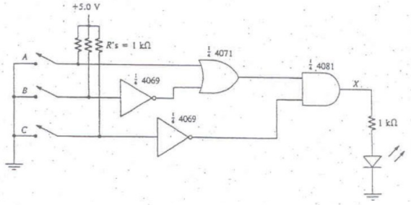

Circuit A

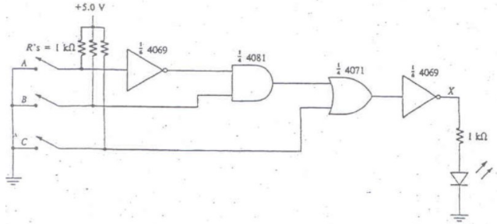

Circuit B

**EXPERIMENTAL PROOF:**

FOR CIRCUIT A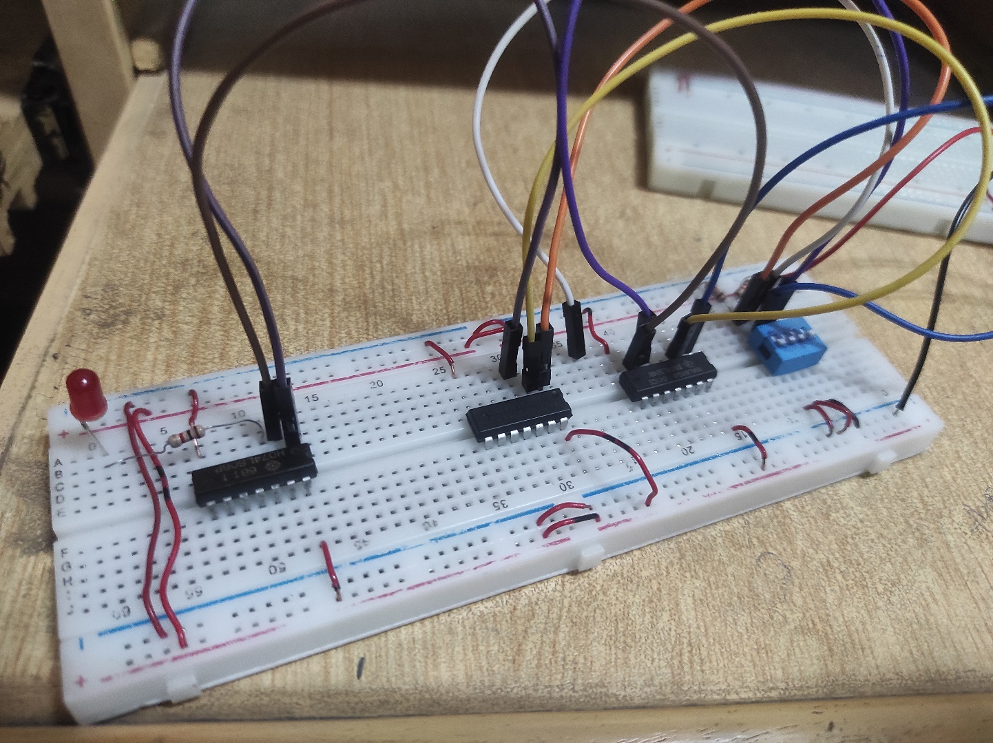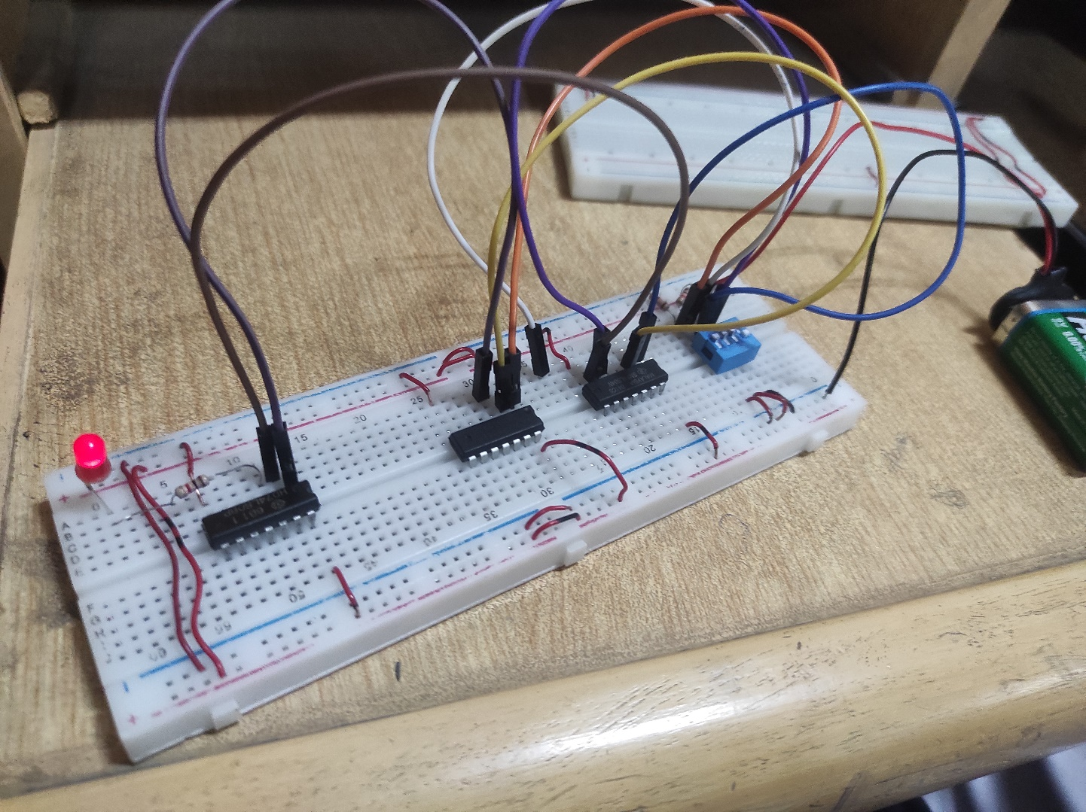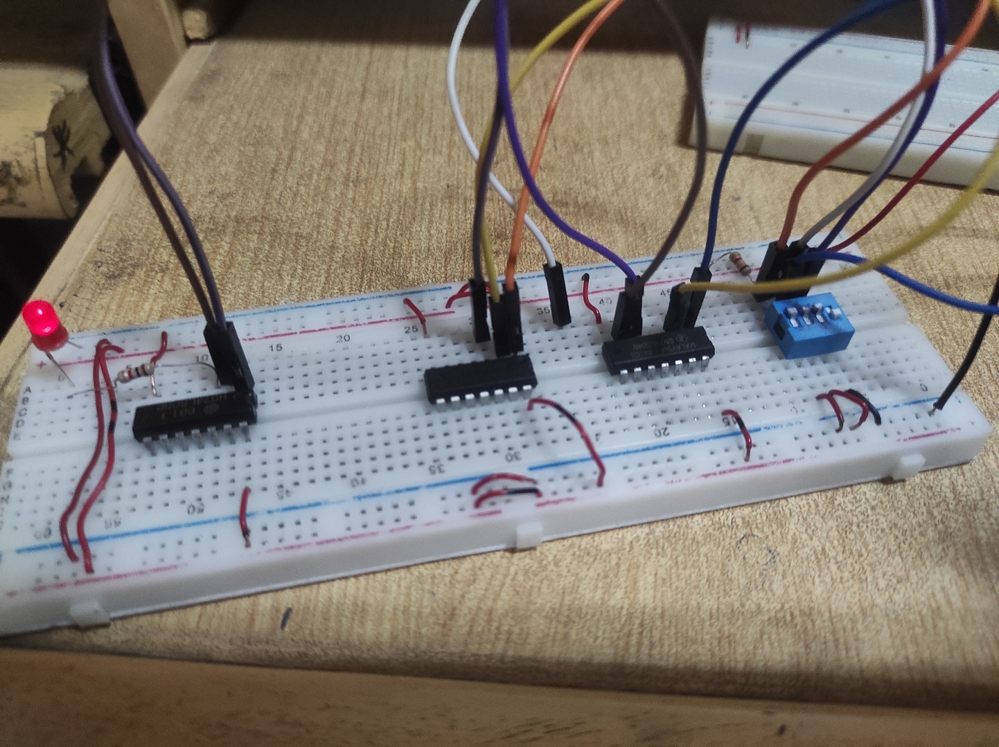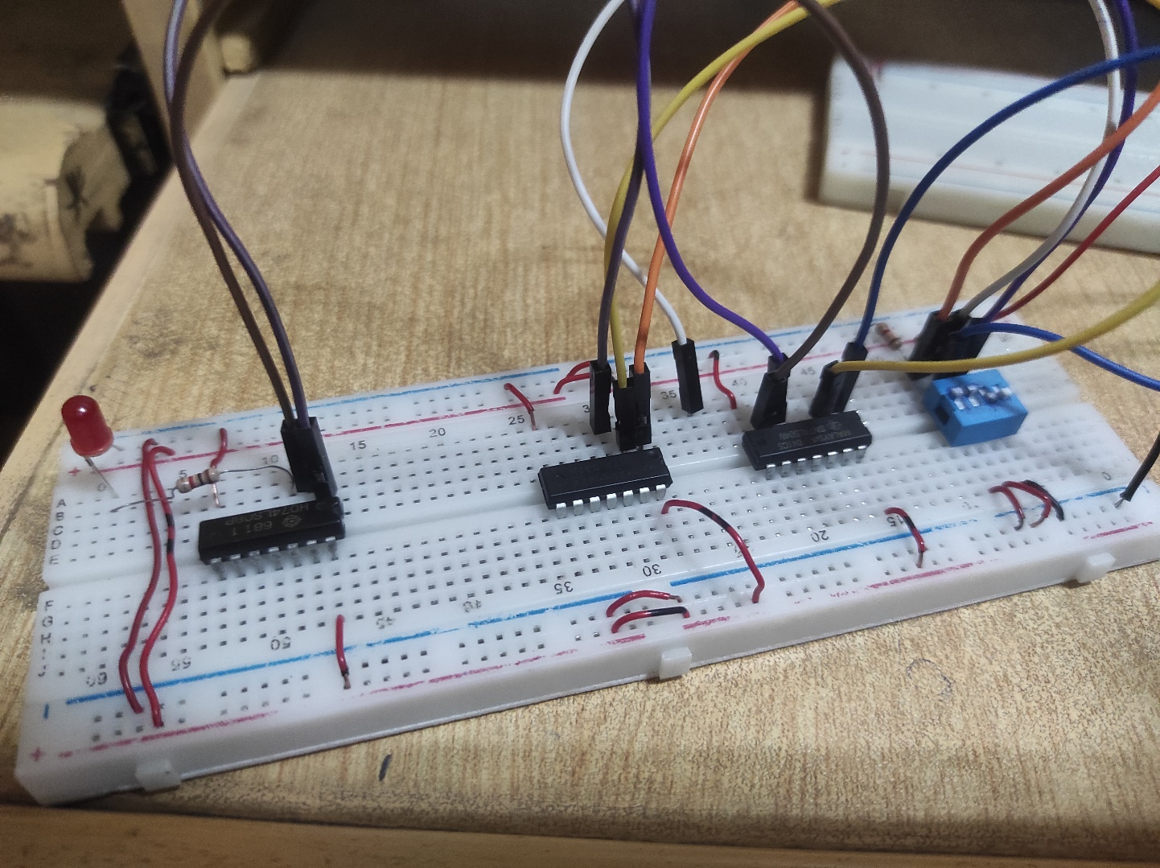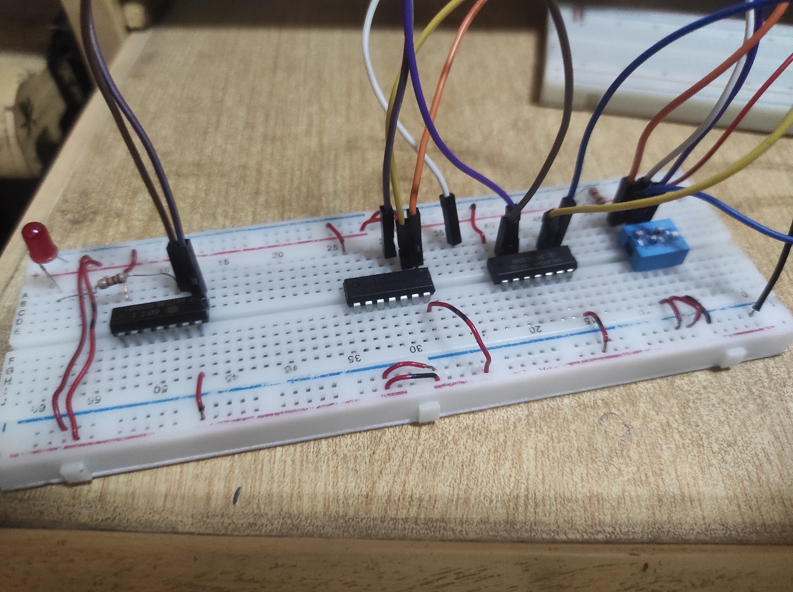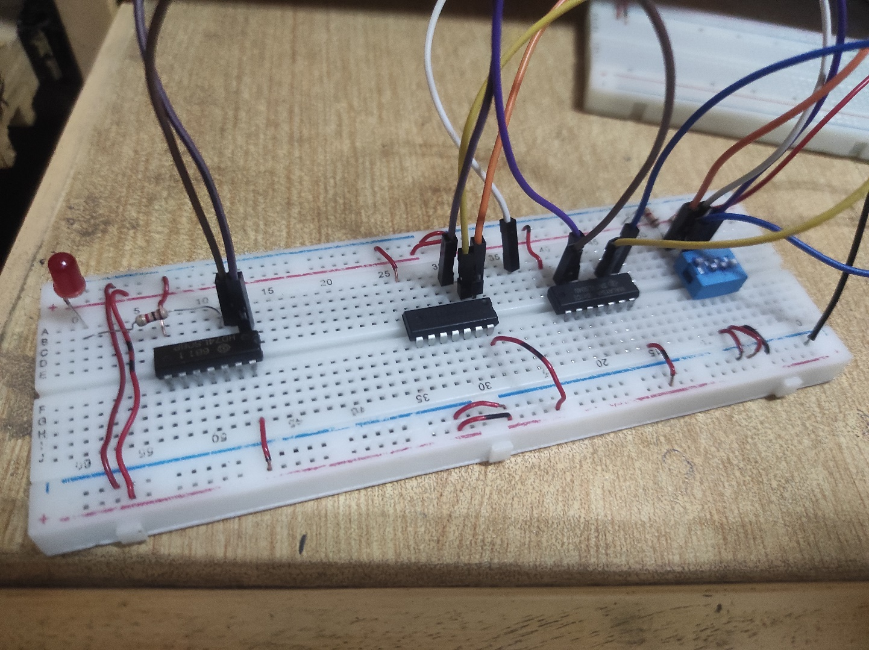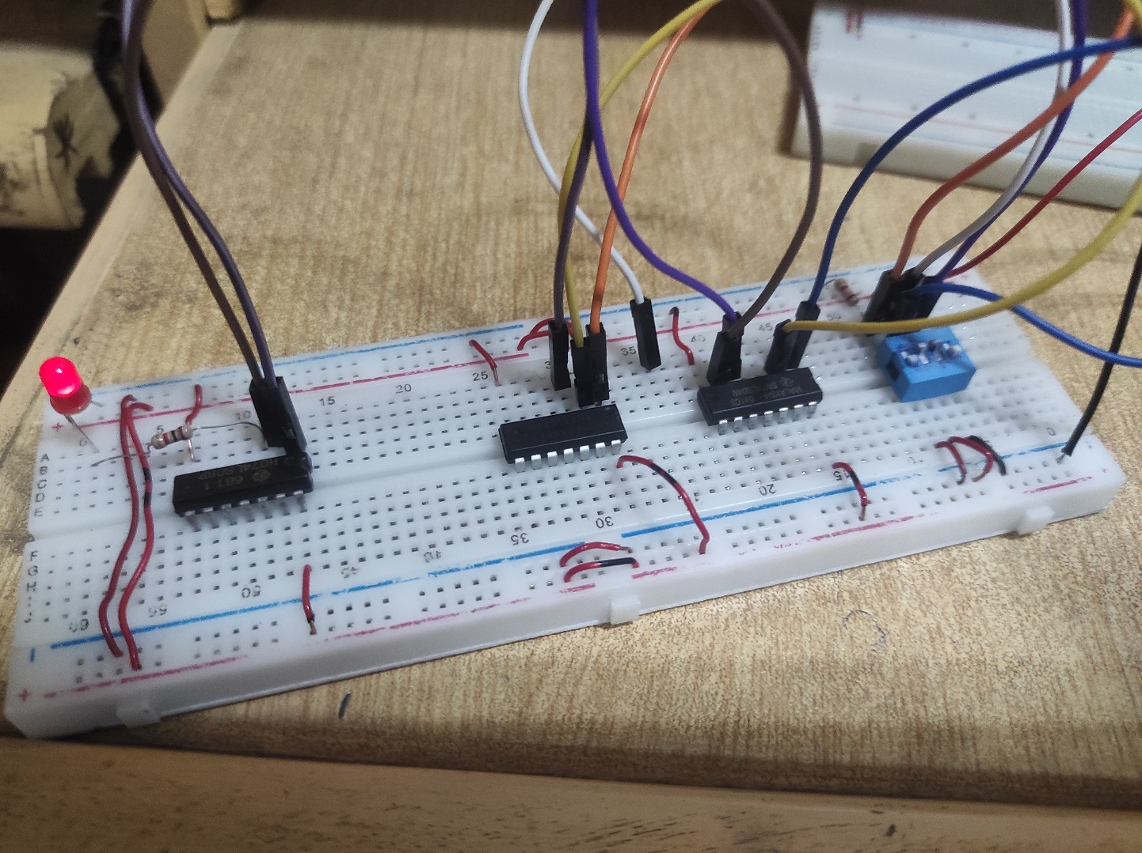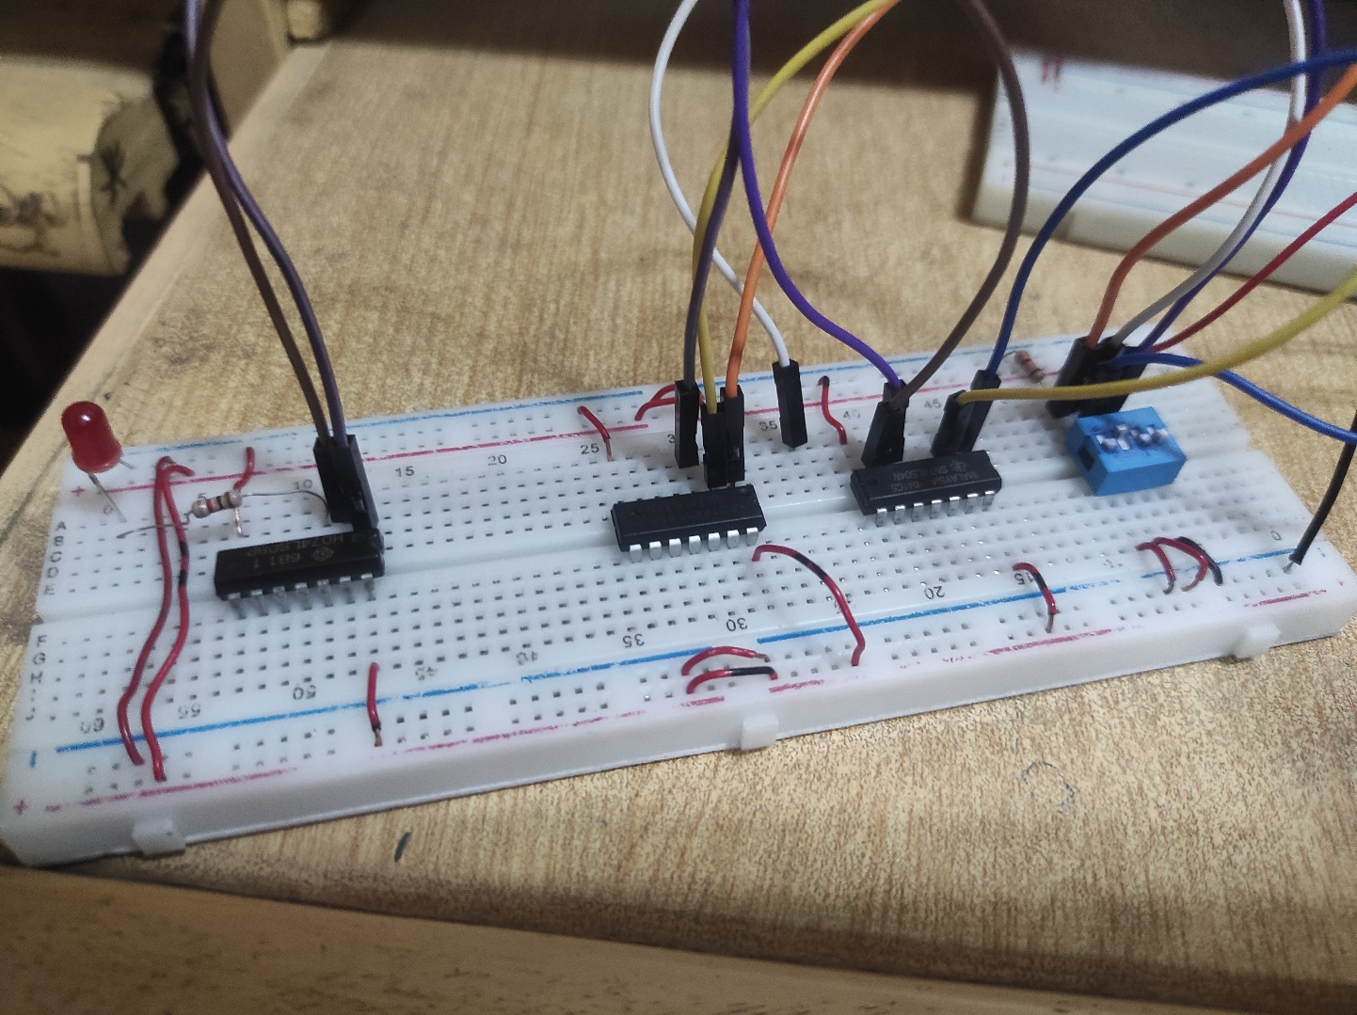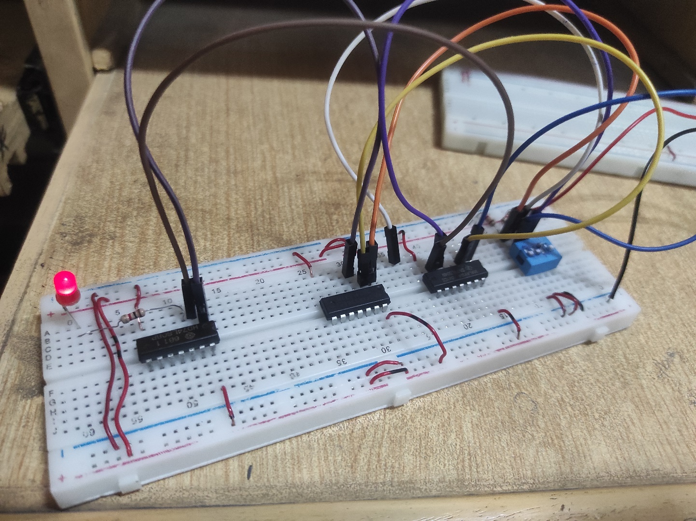

FOR CIRCUIT B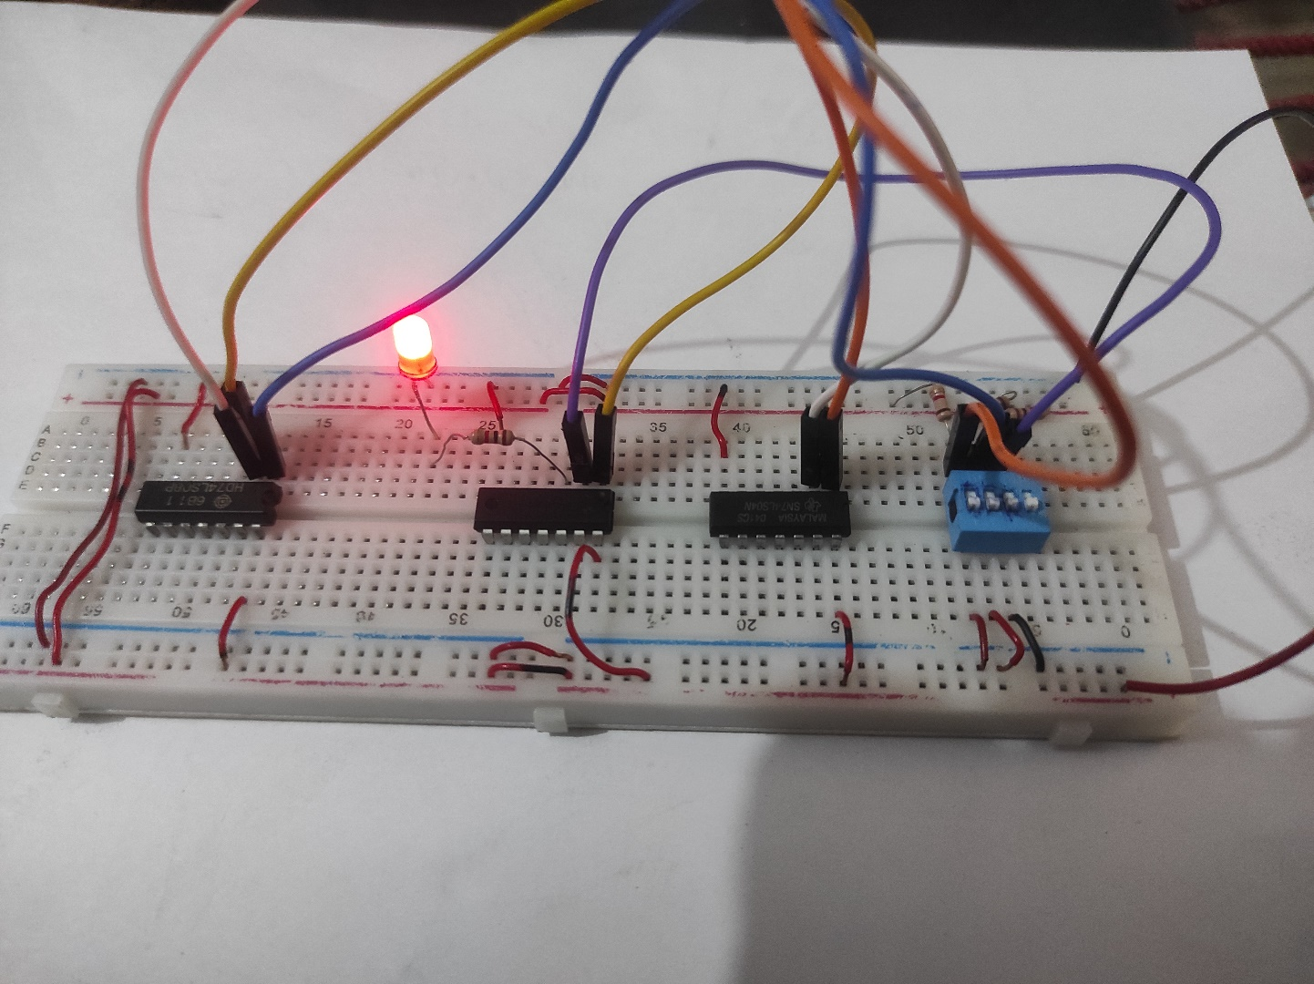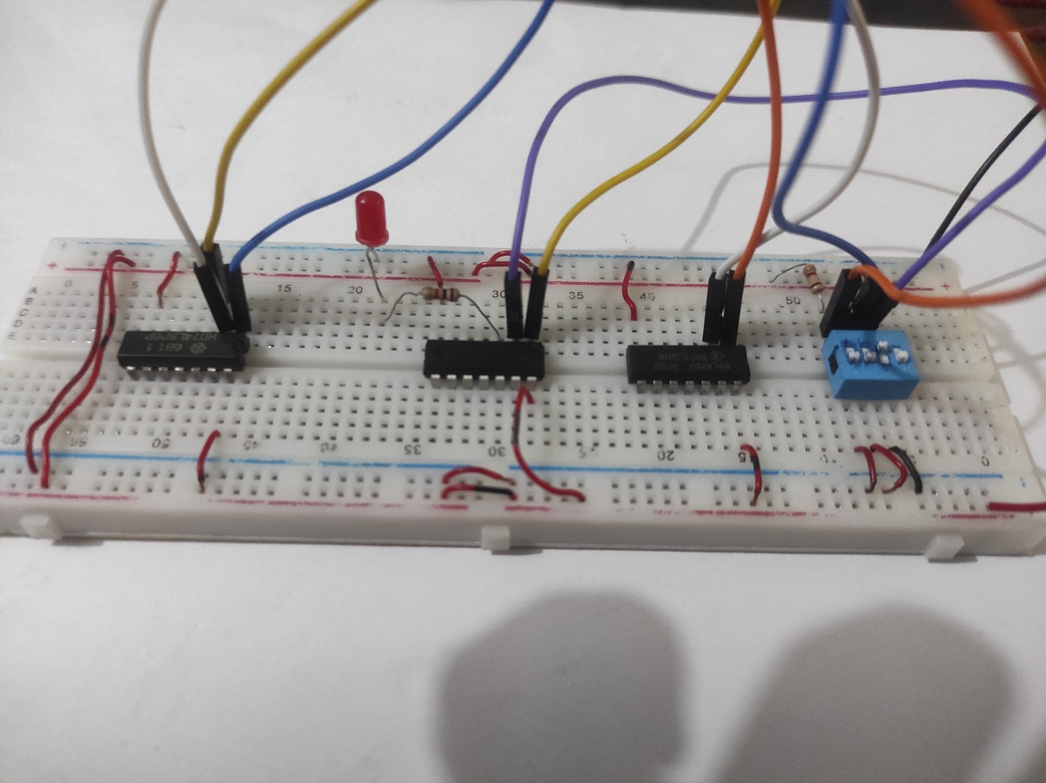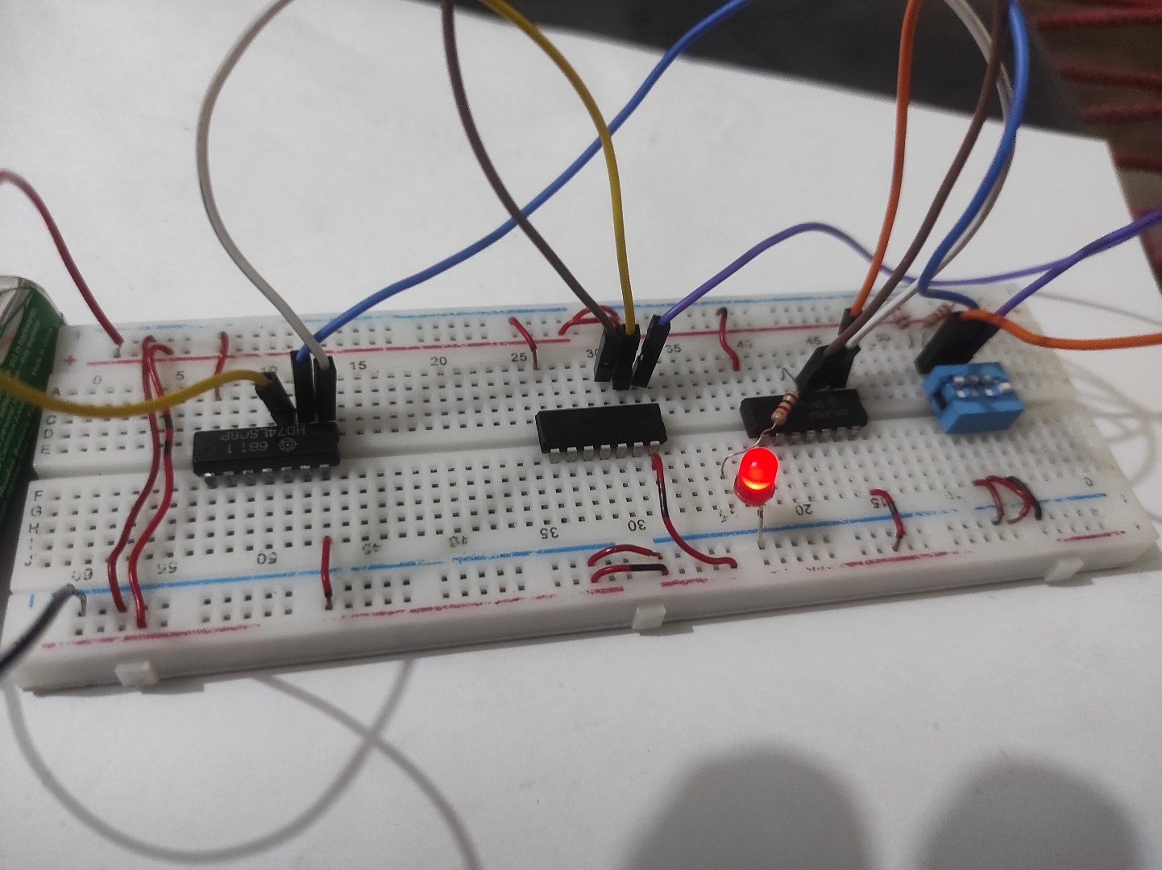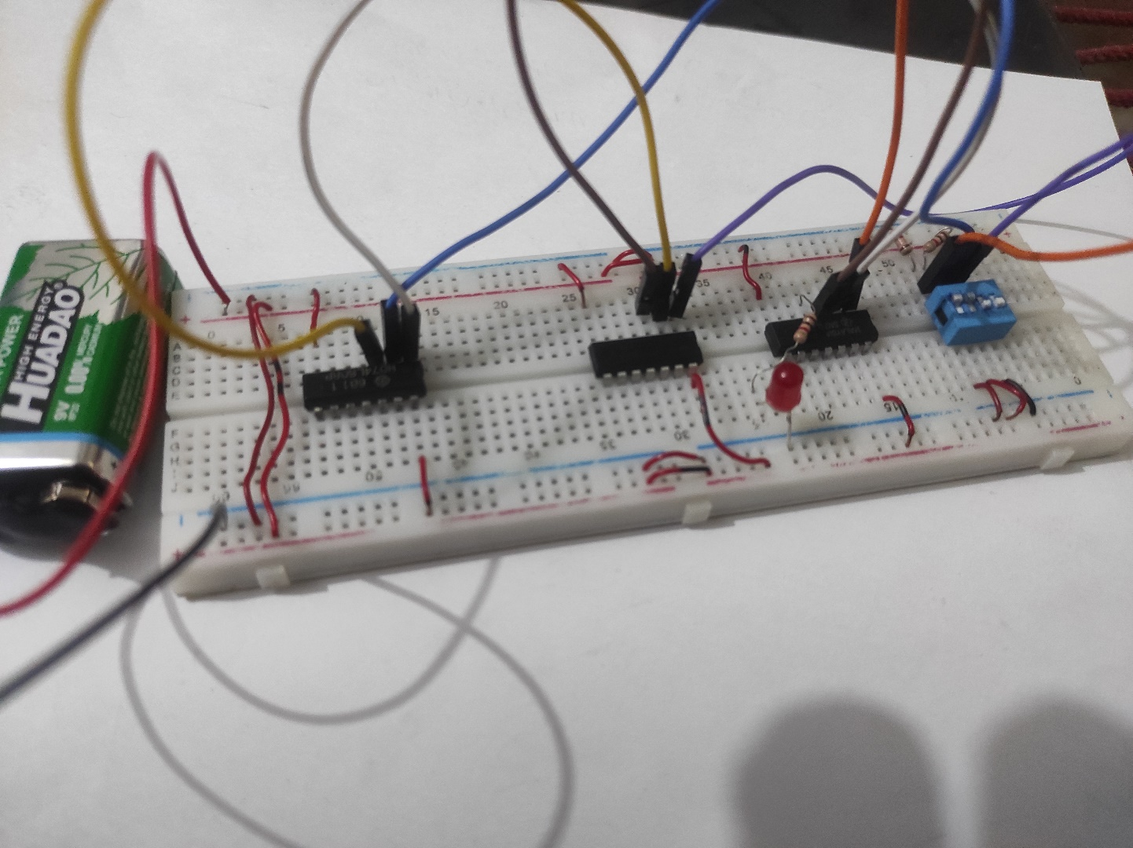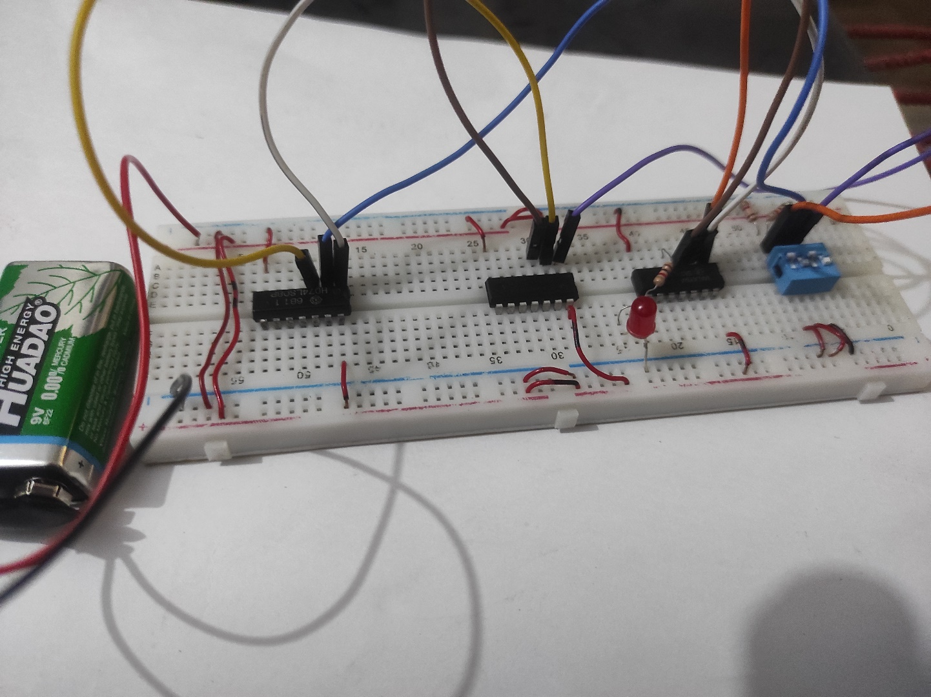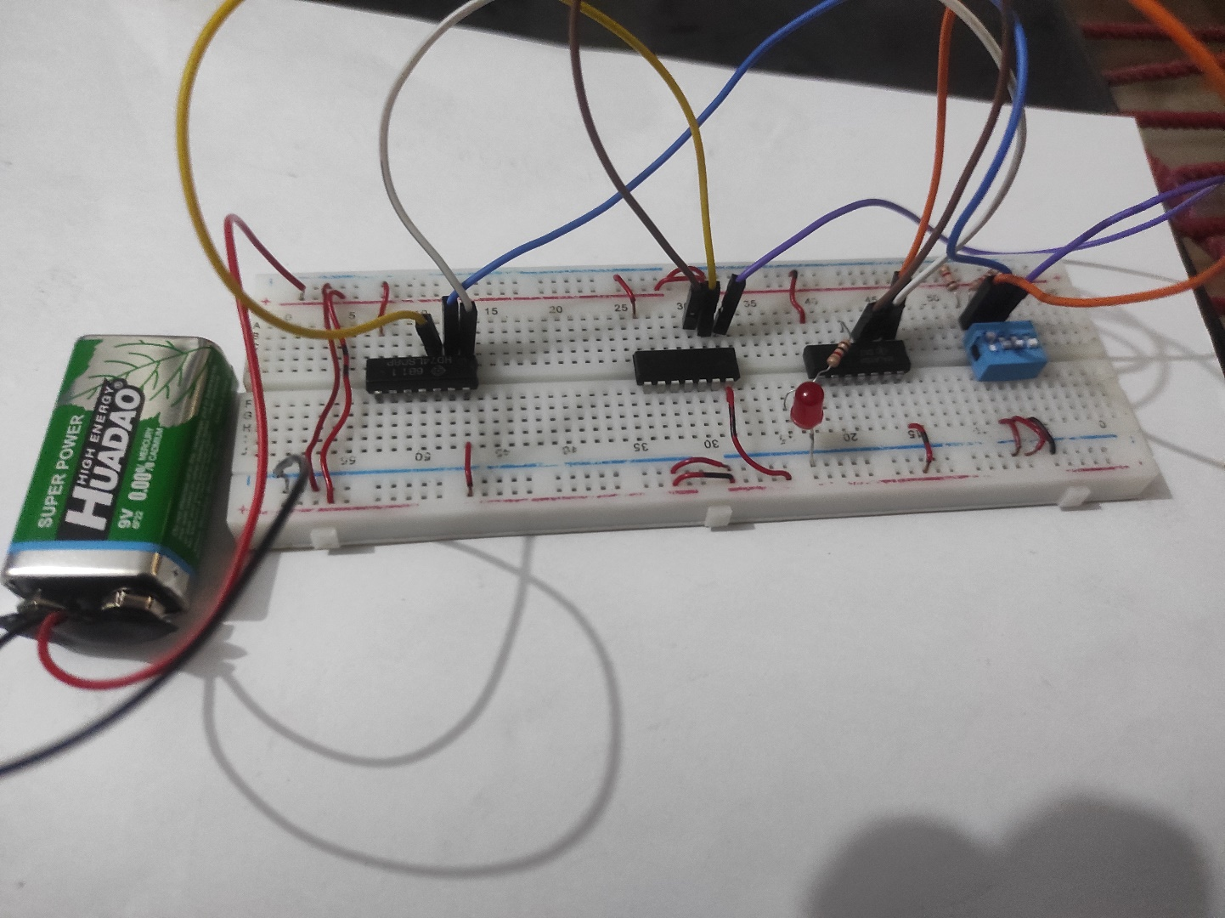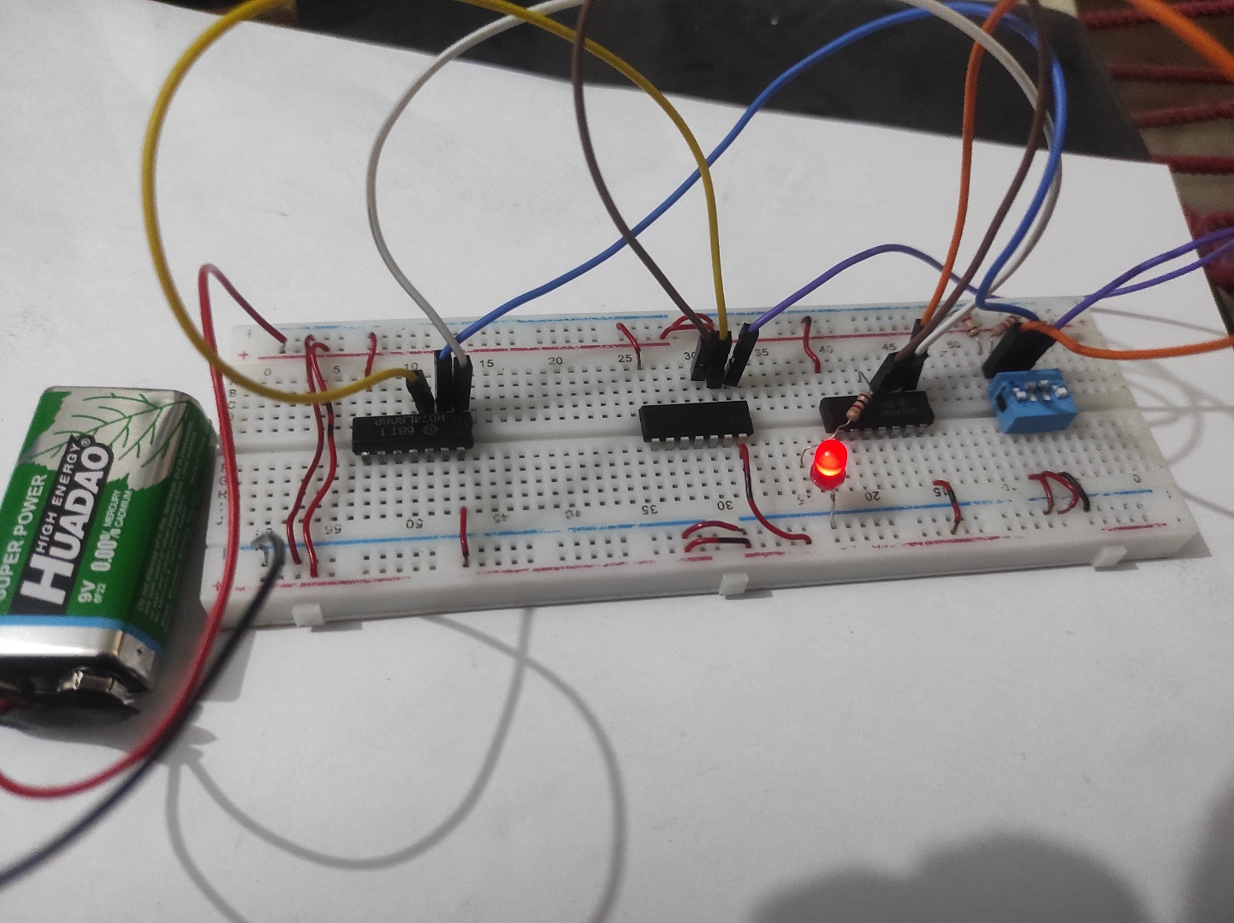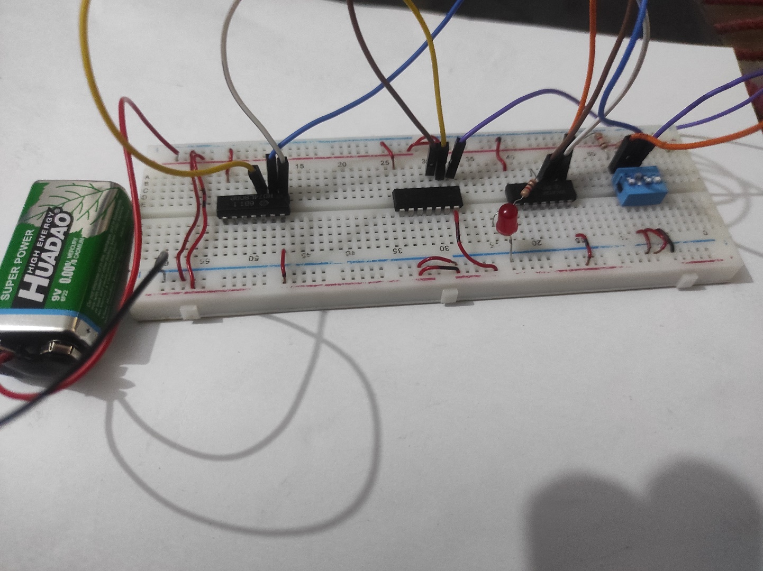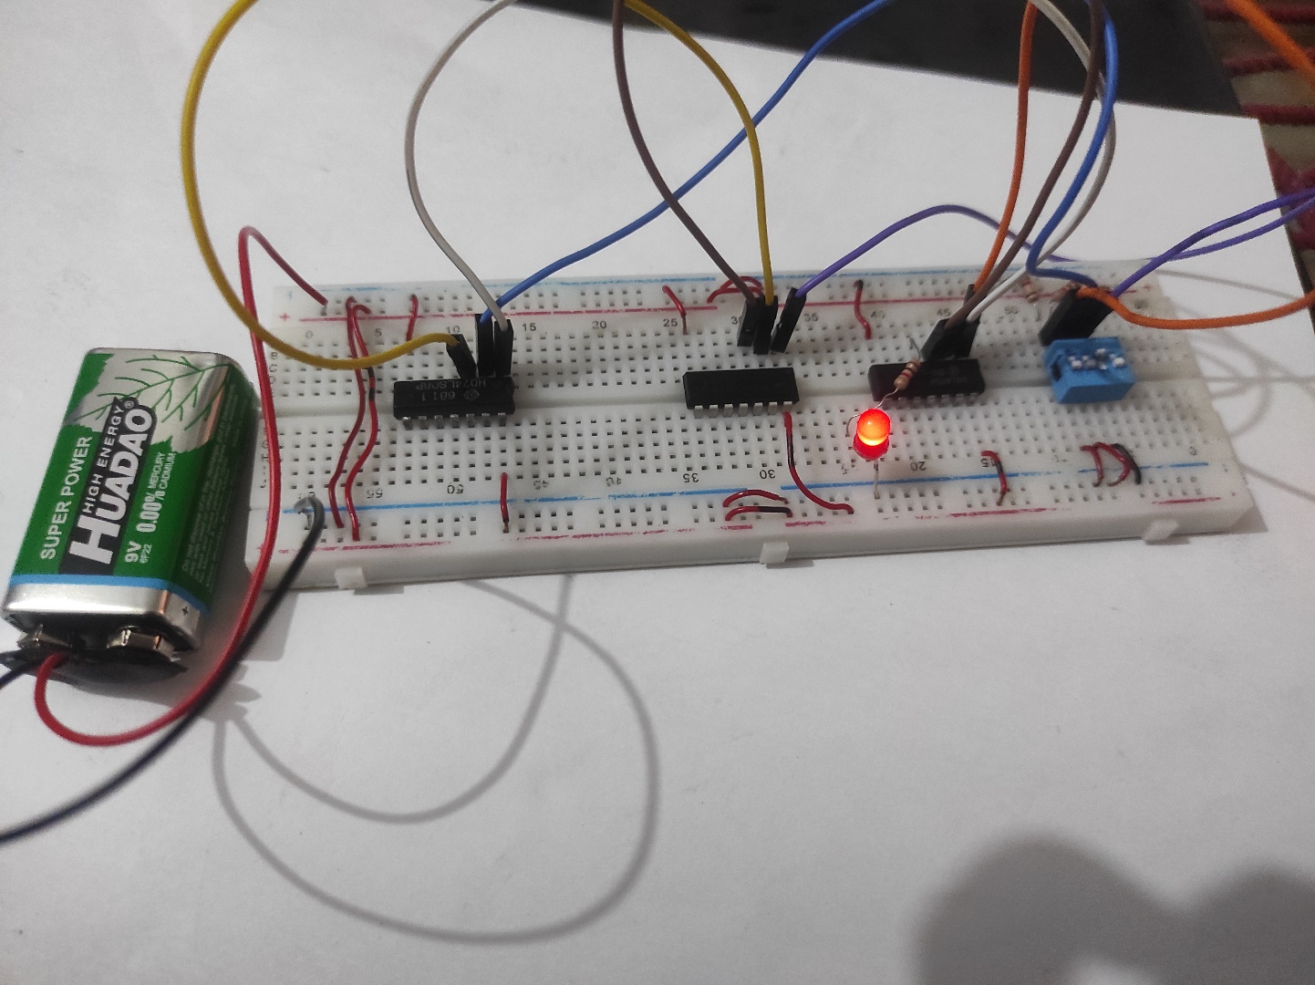

**Truth Table A**

|  |  |  |  |  |
| --- | --- | --- | --- | --- |
| A | B | C | (B’+A) | X=(B’+A).C’ |
| 0 | 0 | 0 | 1 | 1 |
| 0 | 0 | 1 | 1 | 0 |
| 0 | 1 | 0 | 0 | 0 |
| 0 | 1 | 1 | 0 | 0 |
| 1 | 0 | 0 | 1 | 1 |
| 1 | 0 | 1 | 1 | 0 |
| 1 | 1 | 0 | 1 | 1 |
| 1 | 1 | 1 | 1 | 0 |

**Truth Table B**

|  |  |  |  |  |
| --- | --- | --- | --- | --- |
| A | B | C | (A’.B) | X=((A’.B)+C)’ |
| 0 | 0 | 0 | 0 | 1 |
| 0 | 0 | 1 | 0 | 0 |
| 0 | 1 | 0 | 1 | 0 |
| 0 | 1 | 1 | 1 | 0 |
| 1 | 0 | 0 | 0 | 1 |
| 1 | 0 | 1 | 0 | 0 |
| 1 | 1 | 0 | 0 | 1 |
| 1 | 1 | 1 | 0 | 0 |

**ALGEBRAIC PROOF:**

**Solution:**

For first circuit we write,

OA = ((B’+A).C’)

OA = ((A+B’).C’)

For second circuit we write,

OB = ((A’. B)+C)’ (function derived from schematic)

OB = ((A’.B)+C)’ (Using De-Morgan’s rule on outer bracket)

OB = ((A’.B)’.C’) (Using De-Morgan’s rule on inner bracket)

OB = (A+B’.C’)

Hence it is proved that,

OA **=** OB

i.e

**(A+B’.C’) = (A+B’.C’)**